|  |  |
| --- | --- |
| **Project:** | **Provisio** |
| **Course:** | **CSD 460 Capstone** |
| **Description:** | **Group 3**: Kyle Gotzman, Chee Her, Avery Owen,Jonathan Sudhop |
| **Date:** | **2022/9/1** |
| **Version:** | **0.1** |

**TABLE OF CONTENTS**

**Landing Page Test #1** 2

**Developer Test:** 3

**Landing Page Test #2** 6

**Developer Test** 7

**Login Page Test #1** 9

**Developer Test:** 10

**Login Page Test #2** 11

**Developer Test:** 12

**Registration Page Test #1** 13

**Developer Test:** 14

**Registration Page Test #2** 16

**Developer Test:** 17

|  |  |  |  |  |
| --- | --- | --- | --- | --- |
| Test 1 | **Landing Page Test #1** | | | |
|  | **Test Objective:** View and cycle through the images | **Developer:**  **Date tested:** 2022/9/4 | **Peer tester:**  **Date tested:** <yyyy/mm/dd> | |
| **Step** | **Action** | **Expected results:** | **Developer pass/fail** | **Tester pass/fail** |
| 1 | Ensure user is on **Home** page on the Navigation Bar | User should land on the home page of the website | **Yes** | <yes/no> |
| 2 | Click on **Right** **Arrow** of the images | Images should switch and cycle to the left | **Yes** | <yes/no> |
| 3 | Click on **Left** **Arrow** of the images | Image should switch and cycle to the right | **Yes** | <yes/no> |
| **Comments** | **Developer Test:**  Images cycle through smoothly with CSS features to make the transition from one image to another very pleasant to the eye. The Omaha image is the only image that can be easy read but becomes more difficult with the other two images featuring Denver and Los Angeles. The readability of the featured location may be adjusted accordingly with either a change in the image or a change in the color scheme. | | | |

## **Developer Test:**

The default image without clicking on any of the arrows is the **Omaha** Image

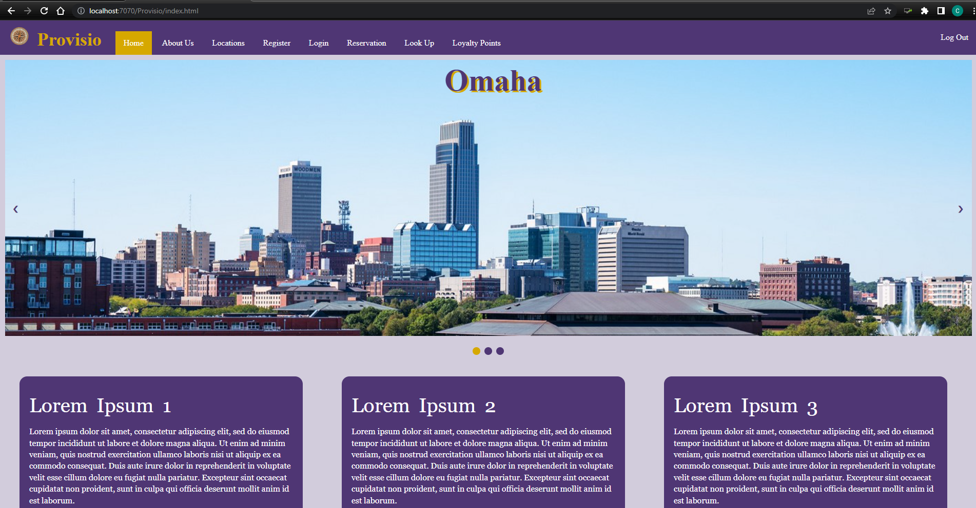

* Clicking on the right arrow when on the Omaha image will display the **Denver** Image
* Clicking on the left arrow when on the Denver image will cycle the image back to the Omaha image

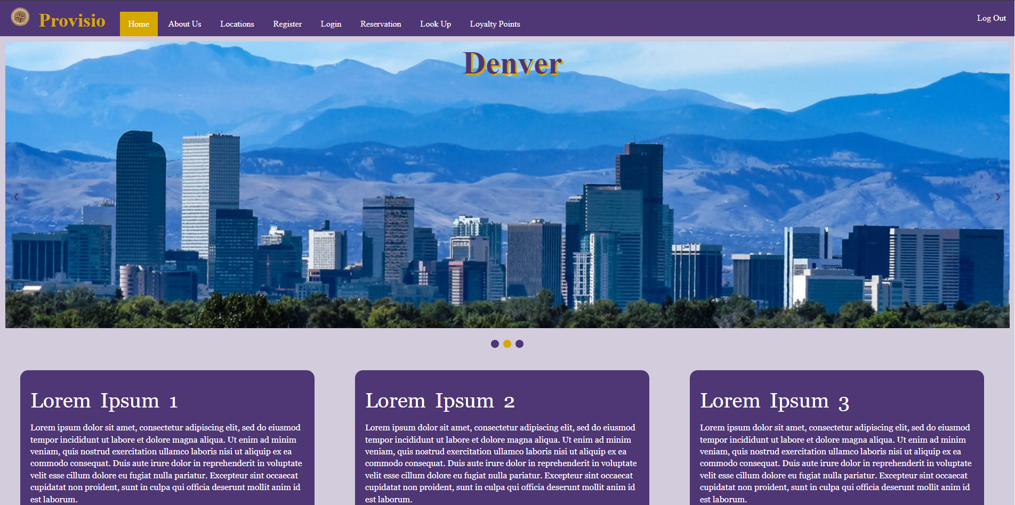

* Clicking on the right arrow when on the Denver image will display the **Los Angeles** Image
* Clicking on the left arrow when on the Los Angeles image will cycle the image back to the Denver image

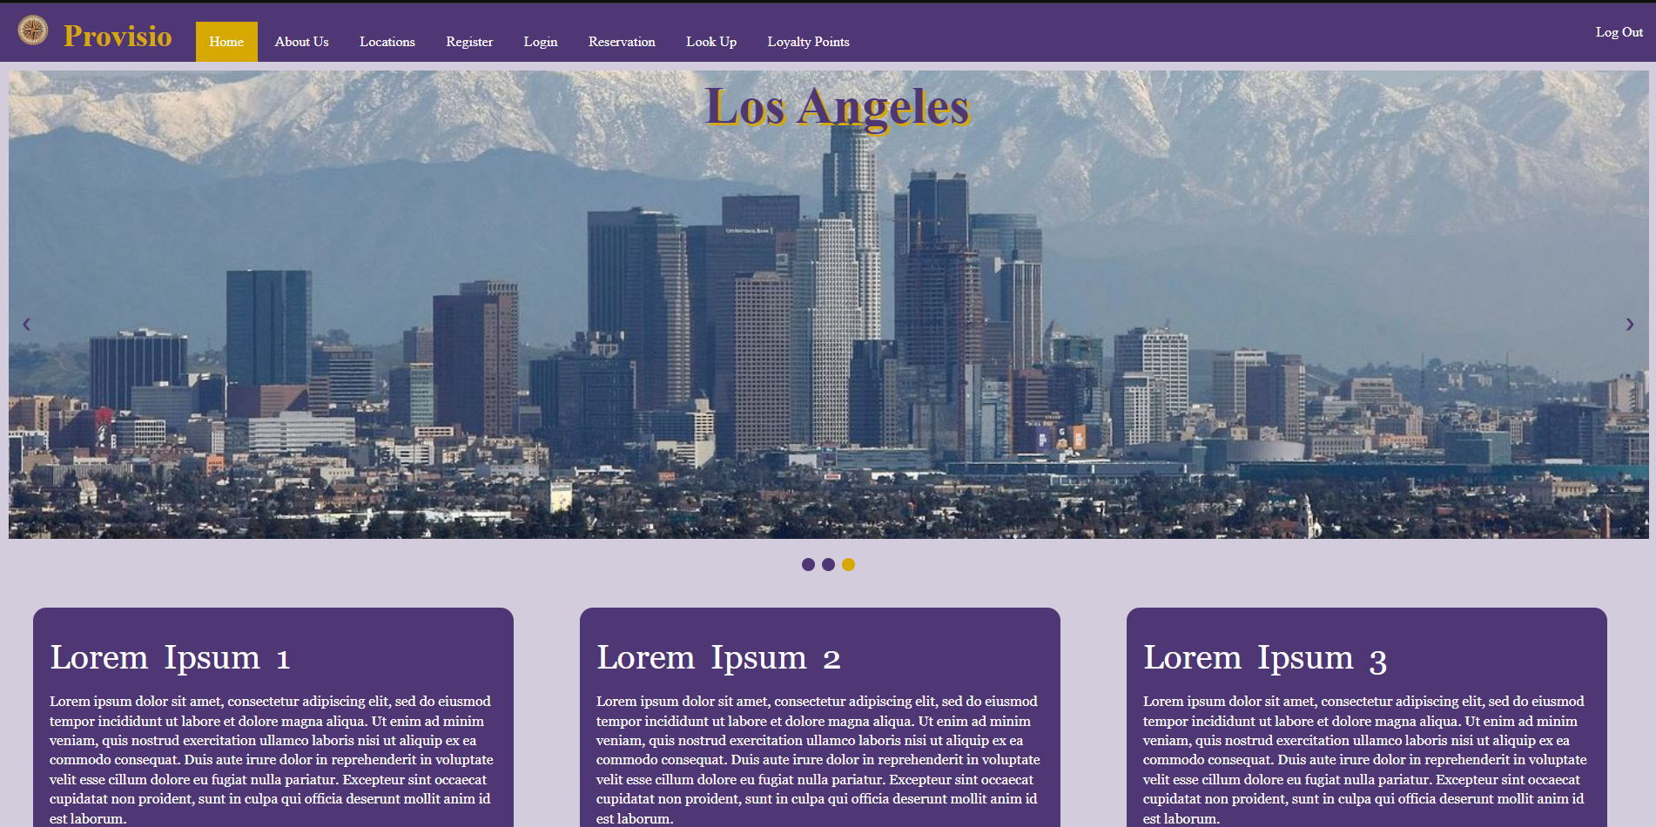

|  |  |  |  |  |
| --- | --- | --- | --- | --- |
| Test 2 | **Landing Page Test #2** | | | |
|  | **Test Objective:** Check to see if the Navigation Bar is working correctly | **Developer:**  **Date tested:** 2022/9/4 | **Peer tester:**  **Date tested:** <yyyy/mm/dd> | |
| **Step** | **Action** | **Expected results:** | **Developer pass/fail** | **Tester pass/fail** |
| 1 | Ensure user is on **Home** page on the Navigation Bar | User should land on the home page of the website | **Yes** | <yes/no> |
| 2 | On the **Navigation bar**, click on **Login** | User should be redirected to the **Login** page | **Yes** | <yes/no> |
| 3 | Click the **browser** back button to navigate back to the Home page | User should be redirected back to the Home page of the site | **Yes** | <yes/no> |
| 4 | On the **Navigation bar**, click on **Register** | User should be redirected to the **Register** page | **Yes** | <yes/no> |
| **Comments** | **Developer Test:**  The navigation bar is working correctly with the index page redirecting to the Login and Register pages that have been created as of this point in the development. The navigation bar also has CSS to it that allows the use to visually see which page it will be directed to with a hover style. Upon landing on the pages of Login and Register from the Home page, the navigation bar’s Home page when clicked will also redirect the user back to the Home page. | | | |

## **Developer Test**

Hovering on the navigation bar’s **Login** will highlight it before being clicked

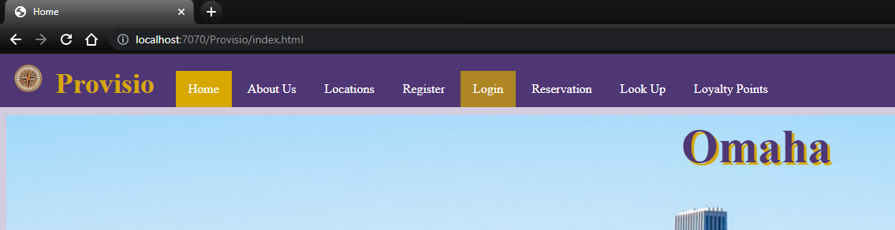

Clicking on the navigation bar’s **Login** will direct the user to the **Login** page

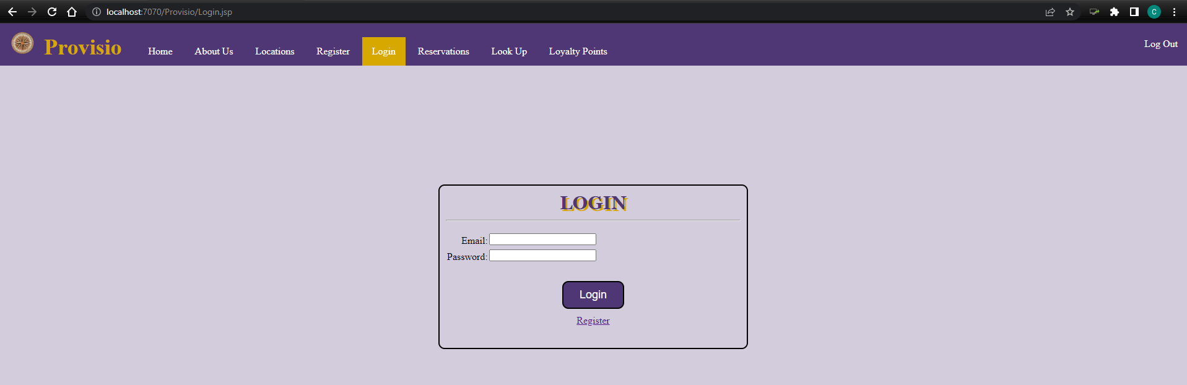

Hovering on the navigation bar’s **Register** will highlight it before being clicked

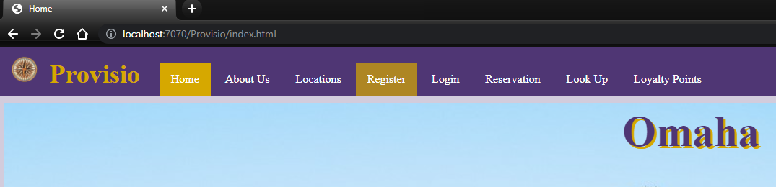

Clicking on the navigation bar’s **Register** will direct the user to the **Register** page

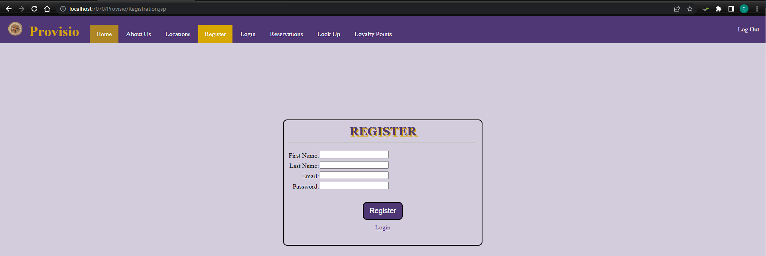

|  |  |  |  |  |
| --- | --- | --- | --- | --- |
| Test 3 | **Login Page Test #1** | | | |
|  | **Test Objective:** Successfully login with correct username and password | **Developer:**  **Date tested:** 2022/9/4 | **Peer tester:**  **Date tested:** <yyyy/mm/dd> | |
| **Step** | **Action** | **Expected results:** | **Developer pass/fail** | **Tester pass/fail** |
| 1 | Click on the **Login** page on the Navigation Bar | User should be redirected to the Login page of the website | **Yes** | <yes/no> |
| 2 | Click on the **Email textbox** | Text cursor should appear in textbox | **Yes** | <yes/no> |
| 3 | Type user email “**AdaW93@example.com**” into the textbox | The user email should be displayed in the textbox | **Yes** | <yes/no> |
| 4 | Click on the **Password textbox** | Text cursor should appear in textbox | **Yes** | <yes/no> |
| 5 | Type the user password “**Ada1**” into the textbox | The user password should be in inputted to the textbox but encrypted | **Yes** | <yes/no> |
| 6 | Click on the **Login** button below the username and password | User should login successfully and be redirected | **Yes** | <yes/no> |
| **Comments** | **Developer Test:**  On the top right corner of the website, there is a “Log Out” button that indicates that the user is already logged in before even doing anything. This will need to be fixed to either be the actual Login instead of being in the navigation bar or invisible/disabled before the user logs in. Other than this, the login with the correct credentials allows the user to login with no issues. | | | |

## **Developer Test:**

Type user’s email and password into login textbox

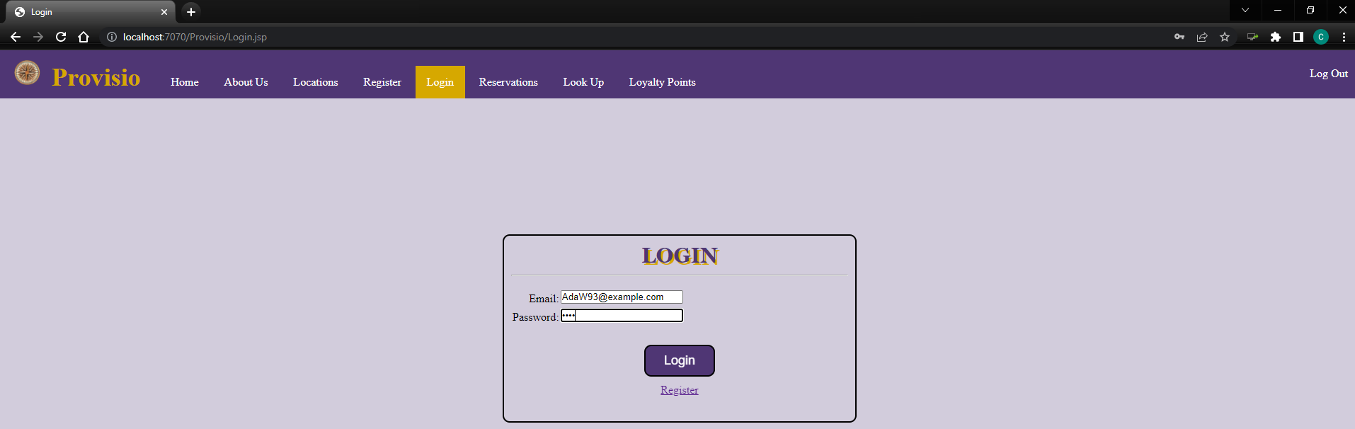

Upon clicking the **Login Button**, user should be notified that they have logged in successfully

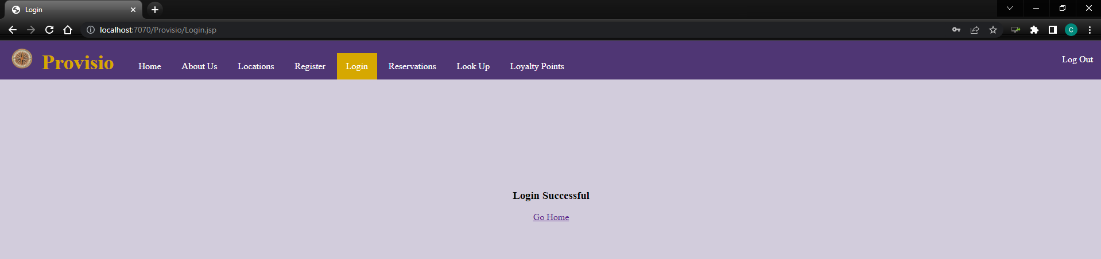

|  |  |  |  |  |
| --- | --- | --- | --- | --- |
| Test 4 | **Login Page Test #2** | | | |
|  | **Test Objective:** Failure to login with both incorrect username and incorrect password | **Developer:**  **Date tested:** <yyyy/mm/dd> | **Peer tester:**  **Date tested:** <yyyy/mm/dd> | |
| **Step** | **Action** | **Expected results:** | **Developer pass/fail** | **Tester pass/fail** |
| 1 | Click on the **Login** page on the Navigation Bar | User should be redirected to the Login page of the website | **Yes** | <yes/no> |
| 2 | Click on the **Email textbox** | Text cursor should appear in textbox | **Yes** | <yes/no> |
| 3 | Type user email “**notausername**” into the textbox | The user email should be displayed in the textbox | **Yes** | <yes/no> |
| 4 | Click on the **Password textbox** | Text cursor should appear in textbox | **Yes** | <yes/no> |
| 5 | Type the user password “**incorrectpassword**” into the textbox | The user password should be in inputted to the textbox but encrypted | **Yes** | <yes/no> |
| 6 | Click on the **Login** button below the username and password | Login should fail with notification to the user stating that the email or password was incorrect | **Yes** | <yes/no> |
| **Comments** | **Developer Test:**  Entering incorrect email and password into the textbox works as intended. Clicking on the login button notifies the user that there is an error of the user either entering the incorrect username or password. One thing that may need to be addressed for consistency would be for the Login page is the use of either an email or username. In the database, it states email being the email and not a username. This is something that will need to be addressed.  As stated in a previous test, the “Log Out” should be addressed to either be disabled while the user has not logged in. | | | |

## **Developer Test:**

Entering both incorrect username and password into the login textbox

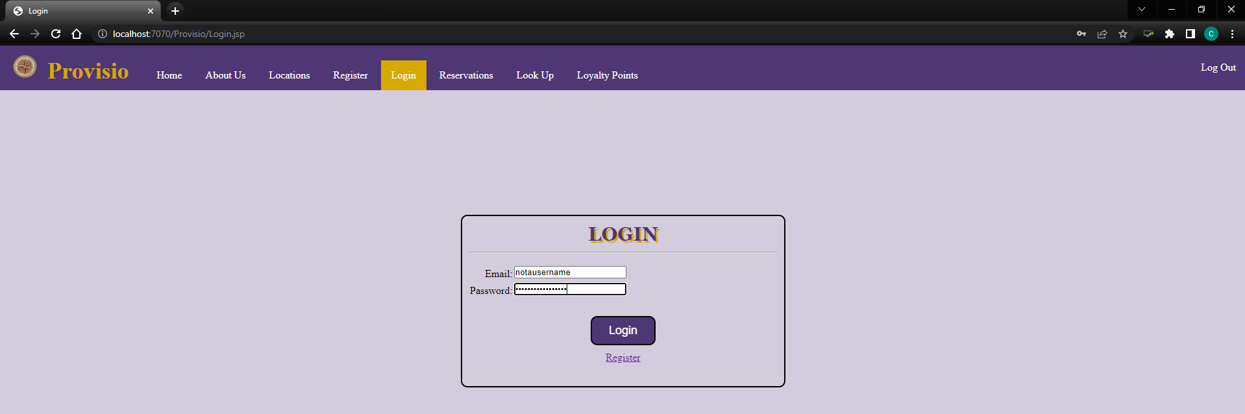

Upon clicking on the Login Button while entering incorrect credentials of both email and password, the user will be notified that there is an error

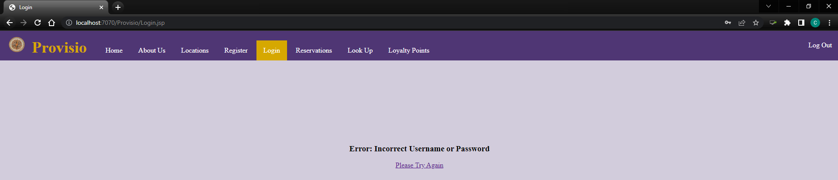

|  |  |  |  |  |
| --- | --- | --- | --- | --- |
| Test 5 | **Registration Page Test #1** | | | |
|  | **Test Objective:** Successfully register to the site with the correct information | **Developer:**  **Date tested:** 2022/9/4 | **Peer tester:**  **Date tested:** <yyyy/mm/dd> | |
| **Step** | **Action** | **Expected results:** | **Developer pass/fail** | **Tester pass/fail** |
| 1 | Click on the **Register** page on the Navigation Bar | User should be redirected to the **Register** page of the website | **Yes** | <yes/no> |
| 2 | Click on the **First Name textbox** | Text cursor should appear in textbox | **Yes** | <yes/no> |
| 3 | Enter your **First Name** into the textbox (Cannot be empty) | User’s **First Name** should appear in the textbox | **Yes** | <yes/no> |
| 4 | Click on the **Last Name textbox** | Text cursor should appear in textbox | **Yes** | <yes/no> |
| 5 | Enter your **Last Name** into the textbox (Cannot be empty) | User’s **Last Name** should appear in the textbox | **Yes** | <yes/no> |
| 6 | Click on the **Email textbox** | Text cursor should appear in textbox | **Yes** | <yes/no> |
| 7 | Enter an **Email** into the textbox (Cannot be empty) | User’s **Email** should appear in the textbox | **Yes** | <yes/no> |
| 8 | Click on the **Password textbox** | Text cursor should appear in textbox | **Yes** | <yes/no> |
| 9 | Enter a **Password** into the textbox (Cannot be empty) | User’s **Password** should appear in the textbox as encrypted | **Yes** | <yes/no> |
| 10 | Click on the **Register Button** | User registration should be successful and informed that account was created | **Yes** | <yes/no> |
| **Comments** | **Developer Test:**  Registering with all required credentials went successfully with no issues. All backend code works correctly with all information being written to the database upon clicking the register button. Not entirely sure if the user should be required to login after they have registered. This is something that should be addressed for the website as sometimes registering does not require the user to login afterwards. I was able to login using the email and password that I used successfully.  As stated in a previous test, the “Log Out” should be addressed to either be disabled while the user has not logged in. | | | |

## **Developer Test:**

Entered credentials to for registering into the website

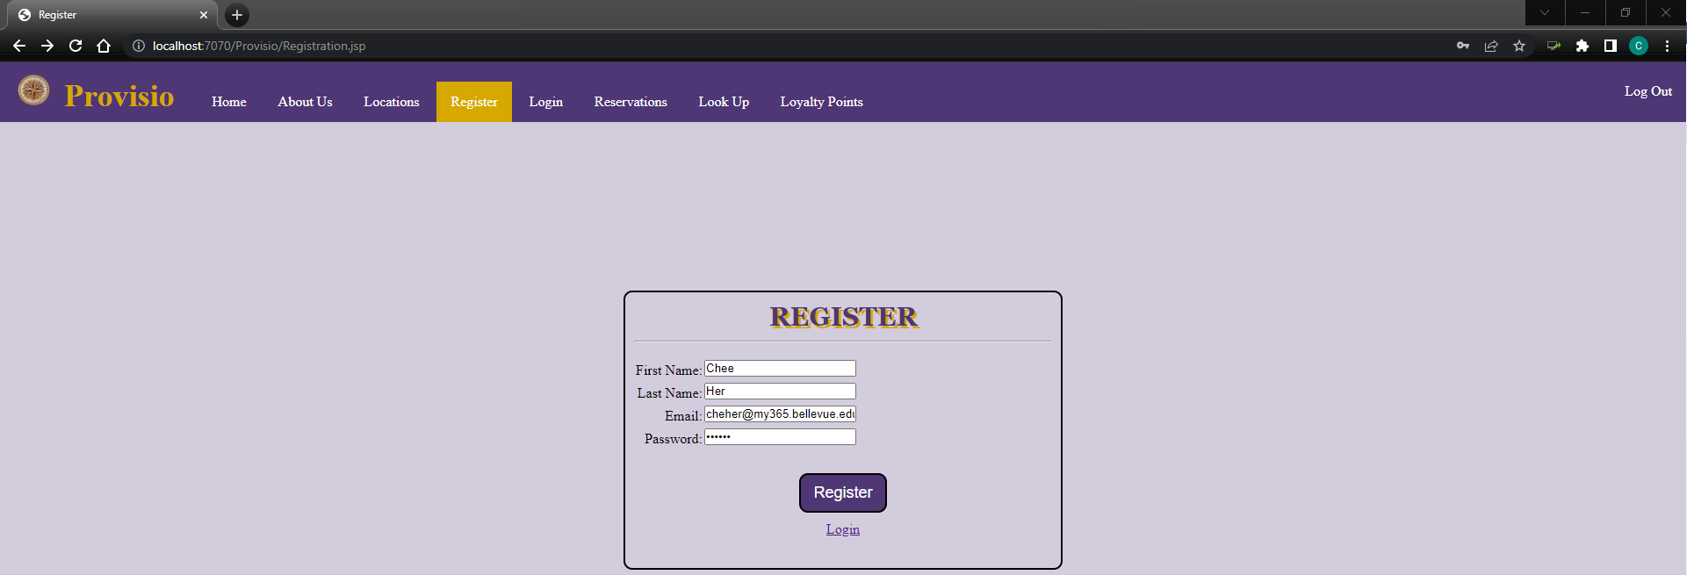

Entering new credentials into the website allows for the user to be registered

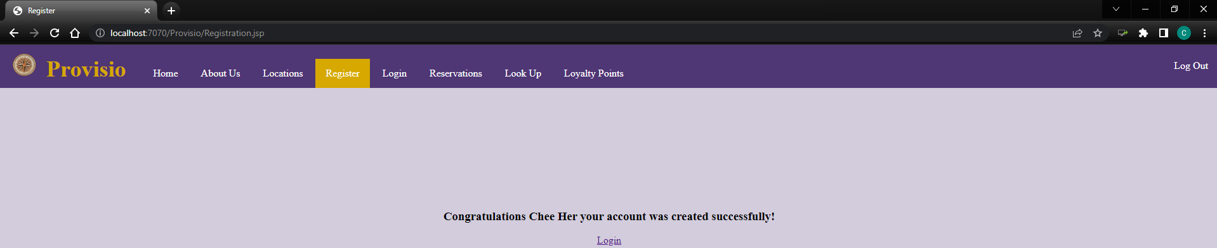

MySQL User table before registering

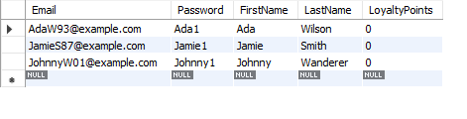

MySQL User table after registering. Showing new user

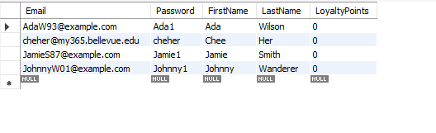

|  |  |  |  |  |
| --- | --- | --- | --- | --- |
| Test 6 | **Registration Page Test #2** | | | |
|  | **Test Objective:** User does not need to register because they already have an account and should therefore click on the **Login** **button** below the **Register button** | **Developer:**  **Date tested:** 2022/9/4 | **Peer tester:**  **Date tested:** <yyyy/mm/dd> | |
| **Step** | **Action** | **Expected results:** | **Developer pass/fail** | **Tester pass/fail** |
| 1 | Click on the **Register** page on the Navigation Bar | User should be redirected to the **Register** page of the website | **Yes** | <yes/no> |
| 2 | Click on the **Login** button below the **Register button** | User should be redirected to the **Login** page | **Yes** | <yes/no> |
| **Comments** | **Developer Test:**  Instead of just having just the Login link below the Register button, it should also state something like “Already have an account? Sign In” with the “Sign In” still being a link to the Login Page. Although still in the early stages of development, styles will need to be adjusted for the Register page for the textbox length as to not have so much white space.  As stated in a previous test, the “Log Out” should be addressed to either be disabled while the user has not logged in. | | | |

## **Developer Test:**

Hovering over the Login link below the Register button will highlight it

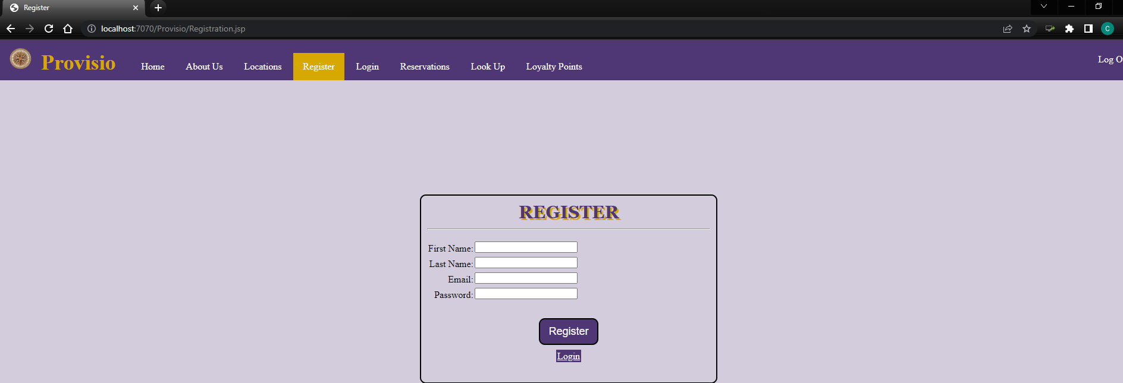

Clicking on the Login link should redirect user to the Login page

